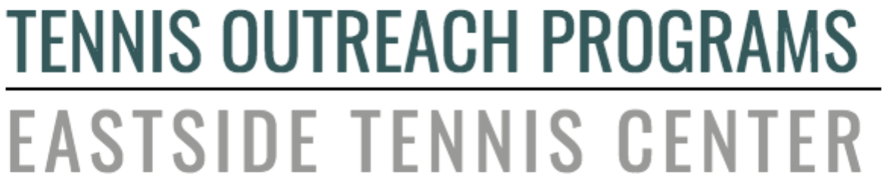
10822 117th Place NE | Kirkland, WA 98033 | 425.658.4046

EMPOWERING YOUTH FOR LIFETIME SUCCESS THROUGH TENNIS,

EDUCATION, FITNESS AND CHARACTER DEVELOPMENT REGARDLESS

OF ECONOMIC CIRCUMSTANCE.

Dear Community or Business Leader,
Tennis Outreach Programs is planning our virtual TOPspin auction Saturday, October 16, 2021. You are invited to become a sponsor for our event and take part in a celebration of our mission, our community, and our commitment to youth tennis.
Eastside Tennis Center, home of Tennis Outreach Programs (TOPs), reaches 3,000 customers monthly through email communications as well as via social media to our 900+ Facebook followers. We anticipate a great turnout for our 2nd annual online event and hope you will consider a sponsorship at one of the following levels:

Tennis Outreach Programs  2021 TOPspin Auction Sponsorship Levels | Platinum Sponsor  $10,000 | Gold Sponsor  $5,000 | Silver Sponsor  $2,500 | Bronze Sponsor  $1,000
Headline Sponsor of TOPspin Auction on all Marketing Promotions | X
Company Name Added to Donor Wall at ETC | X | X
Emcee Recognition at TOPspin Auction | X | X
Facebook & Instagram Sponsorship Shout Out | X | X
Logo Placement During Live Online Show | X | X | X
Logo Placement on TOPspin Auction Email Promotions | X | X | X | X
Logo Placement on 2021 TOPspin Tee-Shirts | X | X | X | X
Logo Placement on TOPspin Website & Posters | X | X | X | X
Logo Placement on ETC Lobby Monitor | X | X | X | X

For returning Sponsors, we want to thank you again for your generous support.

About Us
Tennis Outreach Programs (TOPs) is a 501c (3) nonprofit youth outreach organization. TOPs currently serves over 3,000 youth each year at Eastside Tennis Center. TOPs offers tennis lessons, fitness, life skills training and enrichment classes to support youth in their development. Each year TOPs serves 3,000 kids in our community. The TOPspin Auction raises critical funds to support, expand and enhance our programs, which includes financial assistance to program participants who are eligible and in need. TOPs is especially proud to prioritize at-risk, disadvantaged, and disabled youth.
Children supported in youth activities and sports have consistently shown:
· lower rates of at-risk behaviors
· improved classroom attendance
· higher grades
· increased self-esteem
· improved confidence
· stronger social skills that help them navigate through childhood

Thank you for supporting TOPs. Your sponsorship will make a difference in the lives of the families currently served and will reach more youth in our community. For more information please visit www.topskirkland.org

Thank you very much for your consideration,

Sincerely,
Ursula Heenan Marceil Whitney
TOPspin Auction Project Manager TOPs Founder
ursulaheenan@windermere.com mwhitney@tennisoutreach.org

Checks:
We would sincerely appreciate your support by simply completing the attached sponsorship form and returning it along with your donation or by contacting topsauction@tennisoutreach.org.
Please make checks payable to: Tennis Outreach Programs

Credit Card:
Name (first & last):
Company name (if applicable):
Address:
City/State/Zip:
Credit card #:
Expiration Date:
Security code:
Would you like to cover the credit card fee? $5 flat fee | Yes or No
Total amount to bill credit card: | $
Signature: | X

What we need from you:
Your logo –
Your slogan (if any):
Your website:
If we have questions, what’s a good email:
If we have questions, what’s a good number to call:

